Compilation Techniques Week 4 Forum

Edward Matthew Kurniawan – 2440032316

Part 1

1. Leftmost Derivation:

X -> X + X -> X \* X + X -> a \* X + X -> a \* a + X -> a \* a + (X) ->+ a \* a + (X - X) -> a \* a + (a - X) -> a \* a + (a-a)

Parse Tree:

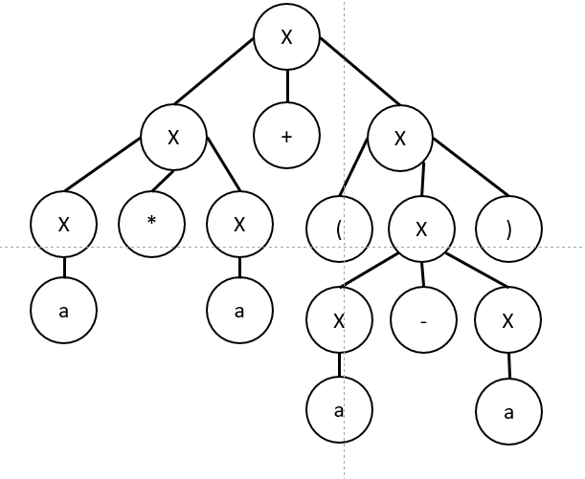

1. Rightmost Derivation:

X -> X \* X -> X \* X + X -> X \* X + (X) -> X \* X + (X - X) -> X \* X + (X - a) -> X \* X + (a - a) -> X \* a + (a - a) -> a \* a + (a - a)

Parse Tree:

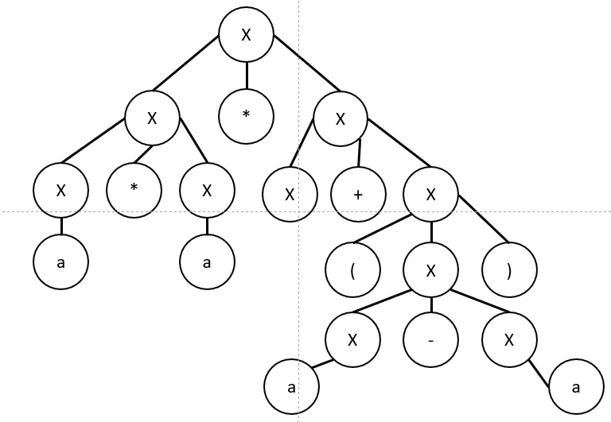

Part 2

1. Leftmost Derivation:

Second Problem:

1. Leftmost derivation:

S -> Expr -> Expr + Term -> Term + Term -> Term \* Factor + Term -> (Expr) \* Factor + Term -> (Expr + Term) \* Factor + Term -> (Term + Term) \* Factor + Term -> (digit + Term) \* Factor + Term -> (2 + Term) \* Factor + Term -> (2+digit) \* Factor + Term -> (2+3) \* Factor + Term -> (2 +3) \* digit + Term -> (2+3) \* 5 + Term -> (2+3) \* 5 + Term / Factor -> (2+3) \* 5 + digit / Factor -> (2+3) \* 5 + 7 / Factor -> (2+3) \* 5 + 7 / (Expr) -> (2+3) \* 5 + 7 / (Expr - Term) -> (2+3) \* 5 + 7 / (Term - Term) -> (2+3) \* 5 + 7 / (digit - Term) -> (2+3) \* 5 + 7 / (9-Term) -> (2+3) \* 5 + 7 / (9 - digit) -> (2+3) \* 5 + 7 / (9-4)

Parse Tree:

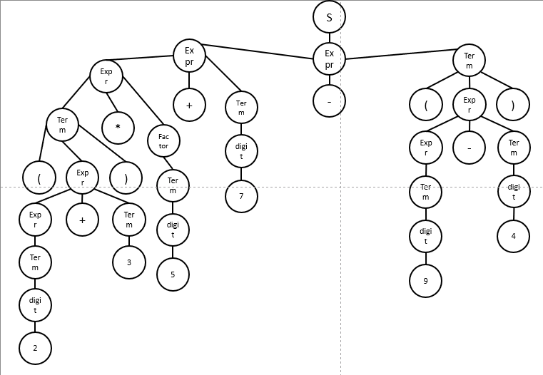

1. Rightmost derivation:

S -> Expr -> Expr + Term -> Expr + Term/ Factor -> Expr + Term / (Expr) -> Expr + Term / (Expr - Term) -> Expr + Term / (Expr - Factor) -> Expr + Term / (Expr - digit) -> Expr + Term / (Expr-4) -> Expr + Term / (Term-4) -> Expr + Term / (Factor-4) -> Expr + Term / (digit-4) -> Expr + Term / (9-4) -> Expr + Factor / (9-4) -> Expr + digit / (9-4) -> Expr + 7 / (9-4) -> Term + 7 / (9-4) -> Term \* Factor + 7 / (9-4) -> Term \* digit + 7 / (9-4) -> Term \* 5 + 7 / (9-4) -> (Expr) \* 5 + 7 / (9-4) -> (Expr + Term) \* 5 + 7 / (9-4) -> (Expr + Factor) \* 5 + 7 / (9-4) -> (Expr + digit) \* 5 + 7 / (9-4) -> (Expr + 3) \* 5 + 7 / (9-4) -> (Expr + 3) \* 5 + 7 / (9-4) -> (Term + 3) \* 5 + 7 / (9-4) -> (Factor + 3) \* 5 + 7 / (9-4) -> (digit + 3) \* 5 + 7 / (9-4) -> (2 + 3) \* 5 + 7 / (9-4)

